**Website Repo:** [Here](https://github.com/jakub-nomad/Unit-15-Hot-Beans-Website)

**Website URL:** [Here](https://jakub-nomad.github.io/Unit-15-Hot-Beans-Website/)

**Designs for the Website**

**Wireframes**

**Home Page Wireframe**

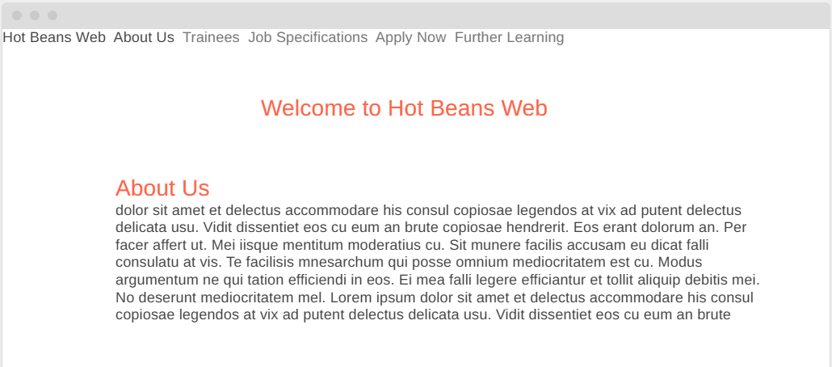

**Justifications of Design Decisions**

**Navigation:** A streamlined and user-friendly navigation bar facilitates intuitive and efficient movement between various sections, enhancing the overall user experience.

**Colour Scheme:** A carefully curated palette of warm tones creates a welcoming atmosphere while seamlessly aligning with the brand's identity and values.

**Form Usability:** Integrated validation processes enhance the application submission experience by minimising errors and ensuring a smooth, efficient user journey. This proactive approach improves accuracy and reduces the likelihood of incomplete or incorrect submissions.

**Feedback-Driven Iterations**

**Navigation Improvements**: Early testers suggested adding hover effects to the navbar links for better usability. This was implemented with a colour change on hover in styles.css.

**Form Enhancement**: Feedback highlighted the need for clearer instructions on required fields in the application form. Placeholder text and tooltips were added to address this.

**Content Readability**: Users recommended increasing font size for the "About Us" section to improve readability, which was updated in the CSS.

**Screenshots of the Completed Website**



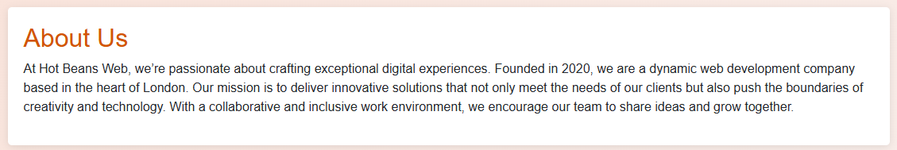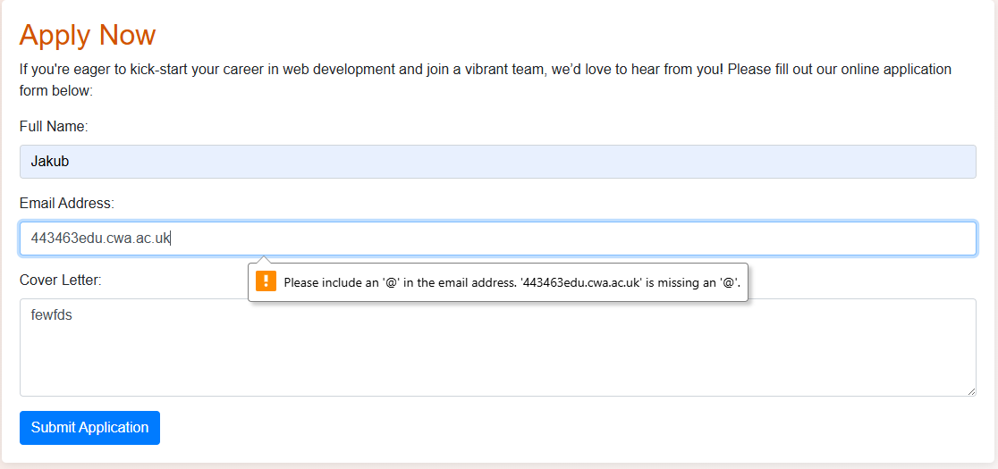

**Evidence of Testing**

|  |  |  |  |
| --- | --- | --- | --- |
| **Test Type** | **What to Test** | **Expected Outcome** | **Results** |
| Functional | Form validation (e.g., email). | Alerts for incomplete inputs. | Success |
| Compatibility | Website on multiple browsers. | Displays consistently. | Success |
| Usability | Feedback on navigation clarity. | Users find it intuitive. | Success |
| Responsive Design | Layout on mobile/tablets. | Adapts without issues. | Success |

**Evaluation of the Design and Development**

**Effectiveness**

The website is designed to align seamlessly with user needs by providing clear, intuitive navigation and a fully responsive layout, ensuring an optimal experience across all devices.

Optimisation efforts have significantly reduced load times while enhancing accessibility, ensuring a faster, more inclusive, and user-friendly experience for all visitors.

**Challenges and Improvements**

**Challenge:** Ensuring seamless form functionality across all browsers to provide a consistent and reliable user experience, regardless of the platform or device used.

**Solution:** Implemented JavaScript validation to enhance form accuracy and reliability, complemented by extensive testing to ensure robust performance across various use cases and platforms.

**Challenge:** Actively gathering diverse user feedback to identify areas for improvement, enhance user experience, and ensure the website meets the needs of a broad audience. **Solution:** Engaged a diverse group of testers with varying skill levels to ensure comprehensive feedback, identify potential usability issues, and enhance the overall user experience.

**Personal Reflection**

Effective organisation and strong time management were essential in ensuring all deadlines were met efficiently, allowing for a structured and productive development process.

Feedback from testing proved invaluable in refining usability, identifying potential issues, and enhancing the overall user experience.

**Evidence of Individual Responsibility and Time Management**

**Task Plan**

A Gantt chart was utilised to strategically outline key milestones, including wireframe completion, testing phases, and deployment, ensuring a structured and efficient project timeline.

Each stage of the project was meticulously tracked to ensure deadlines were adhered to and resources were allocated efficiently, promoting smooth progress and optimal utilisation of time and effort.

**Collaboration Evidence**

Weekly meetings were held with peers and testers to gather valuable feedback, fostering collaboration and ensuring continuous improvements throughout the development process.

Discussions and review sessions were thoroughly documented, with detailed meeting notes and screenshots, ensuring a clear record of decisions, feedback, and progress for future reference and accountability.

Adjustments to the site were implemented based on insightful recommendations from both peers and users, ensuring that the final product aligns closely with user needs and expectations while enhancing overall functionality and user experience.

**Witness Testimony**

**Witness Name:** Ashley Oliver  
**Role:** Tutor  
**Statement:** "The student demonstrated strong time management, regularly meeting project deadlines and incorporating feedback. Their professionalism in collaboration and responsiveness to iterative improvements was evident throughout the project."

**Self-Reflection**

Staying on track necessitated strict adherence to the original timeline, ensuring that each phase was thoroughly completed before progressing to the next. This disciplined approach helped maintain momentum and ensured the project remained on schedule.

Faced challenges in managing multiple revisions resulting from testing but successfully adapted the workflow to accommodate the necessary changes. This flexible approach allowed for continuous improvement while maintaining project momentum and meeting deadlines.

Successfully balanced creativity with functionality, delivering a professional, visually appealing, and highly user-friendly website that meets both aesthetic and practical requirements.